AM000-Asia-China-Warring States-Lunar Lodges-Eight Hexagrams-Twelve Zodical Animals

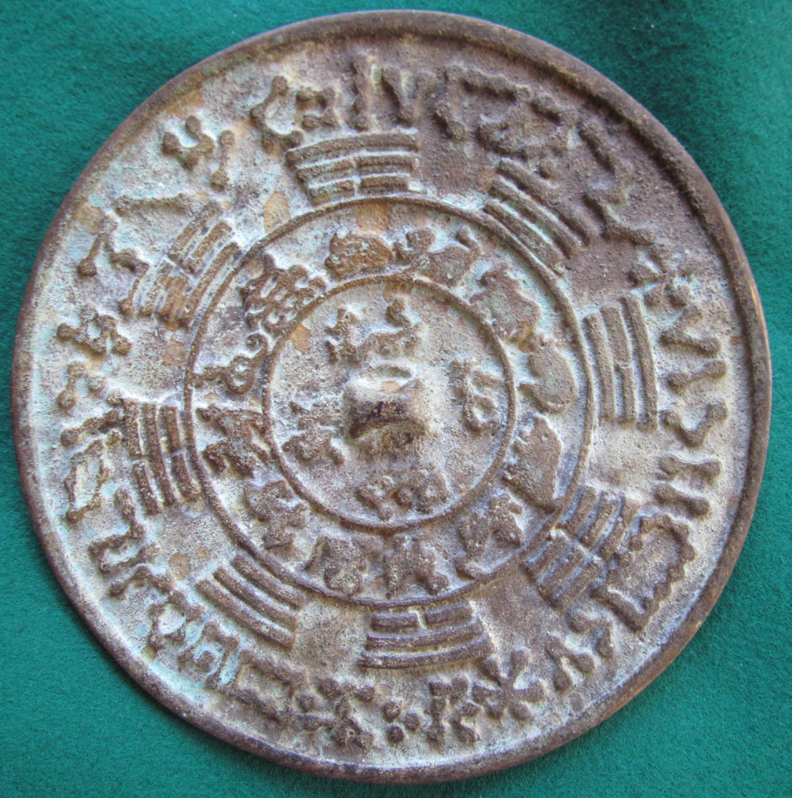

This unusual mirror is a concordance of the 28 lunar lodges, the 8 hexagrams, the 12 zodiacal animals and the animals of the 4 directions.